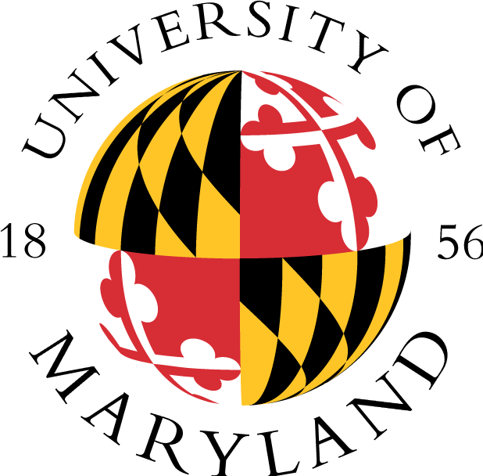

ACADEMIC ACHIEVEMENT PROGRAMS
Ronald E. McNair Post-Baccalaureate Achievement Program
2110 Marie Mount Hall * College Park, MD 20742
(P) 301.405.4749 * (F) 301.314.7255 * www.aap.umd.edu/mcnairprogram

APPLICATION FEE WAIVER REQUEST FOR
UNIVERSITY OF MARYLAND MCNAIR SCHOLARS

TODAY’S DATE

SENT TO (INCLUDING NAME, ADDRESS, FAX, AND EMAIL ADDRESS)

SENT FOR
(Scholar’s Name)

YEARS OF PARTICIPATION

FROM | Wallace Southerland III, Ph.D., Associate Director  2110 Marie Mount Hall, College Park, MD 20742  301-405-4749  wsouther@umd.edu
Please contact me if you have any questions.

Sincerely,
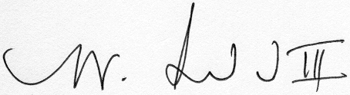
Wallace Southerland III, Ph.D.
Associate Director

Created by: Wallace Southerland, October 5, 2009
Revised by: Wallace Southerland, November 12, 2009
c/WS/McNair Scholars Program/Fee Waiver Form

